Default Value of Q0



Adding X[Not] to Q0

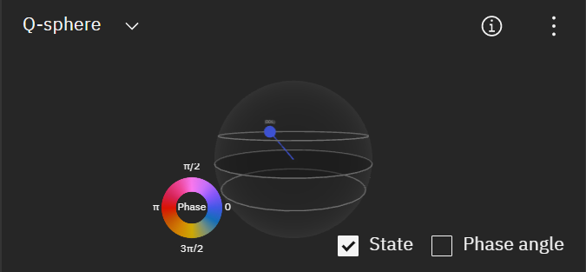

Adding H Gate



To Add C(NOT), we need 2 Q-bits. Q[0] is the control gate, Q1 is the target gate

When Q0 = 0, there is no change in the target gate



When Q[0] = 1, target bit becomes 1



Adding H gate to C(NOT) when Q(0)=1



Adding H gate to C(NOT) when Q(0)=0

